Task1
var subjects = ["Swift", "UIKit", "SwiftUI"]
subjects.append("Networking")
subjects.insert("Testing", at: 1)
subjects.remove(at: subjects.firstIndex(of: "UIKit")!)
print("Sorted subjects:", subjects.sorted())
var registered: Set<String> = ["Arun", "Priya", "Ravi"]
registered.insert("Priya")
registered.insert("Priya")
print("Registered count:", registered.count)
var marks: [String: Int] = [
"Arun": 85,
"Priya": 90,
"Ravi": 78
]
marks["Sita"] = 88
marks["Arun"] = 95
print("Kumar's mark:", marks["Kumar"] as Any)
for name in marks.keys.sorted() {
print("\(name): \(marks[name]!)")
}
if let highest = marks.max(by: { $0.value < $1.value }) {
print("Highest mark:", highest.value)
print("Student:", highest.key)
}
Output
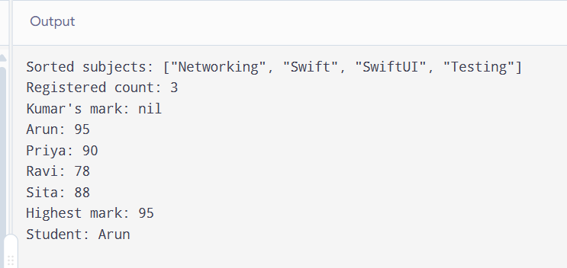
Task2
let sentence = "swift is fun and swift is fast"
let words = sentence.split(separator: " ").map { String($0) }
print("Number of words:", words.count)
let uniqueWords = Set(words)
print("Unique words:", uniqueWords.sorted())
var frequency: [String: Int] = [:]
for word in words {
frequency[word, default: 0] += 1
}
print("Word frequency:")
for word in frequency.keys.sorted() {
print("\(word): \(frequency[word]!)")
}
let rankedWords = frequency.sorted {
if $0.value == $1.value {
return $0.key < $1.key
}
return $0.value > $1.value
}
print("Ranked by frequency:")
for item in rankedWords {
print("\(item.key): \(item.value)")
}
Output:
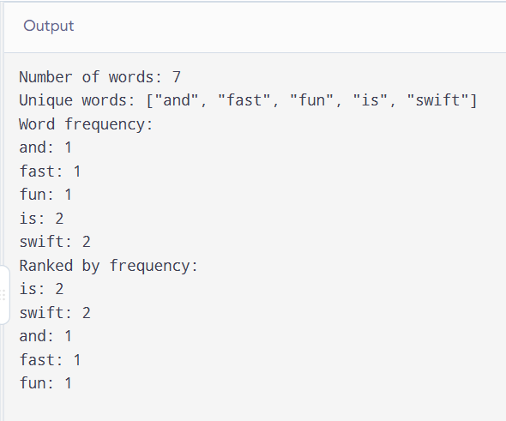
Task3
let swiftClub: Set<String> = ["Anu", "Ben", "Chitra", "Dev"]
let uiClub: Set<String> = ["Chitra", "Dev", "Esha"]
print("Members in both clubs:", swiftClub.intersection(uiClub).sorted())
print("Only Swift club:", swiftClub.subtracting(uiClub).sorted())
print("Everyone:", swiftClub.union(uiClub).sorted())
print("Exactly one club:", swiftClub.symmetricDifference(uiClub).sorted())
let numbers = [3, 1, 3, 2, 1, 4]
var uniqueNumbers: [Int] = []
for number in numbers {
if !uniqueNumbers.contains(number) {
uniqueNumbers.append(number)
}
}

print("Unique numbers:", uniqueNumbers)
output:
